***Challenge 18***

<http://www.lodash.com>

**Goal:**

Reduce case in searches and if two or more words posts then make default hyphon – between words

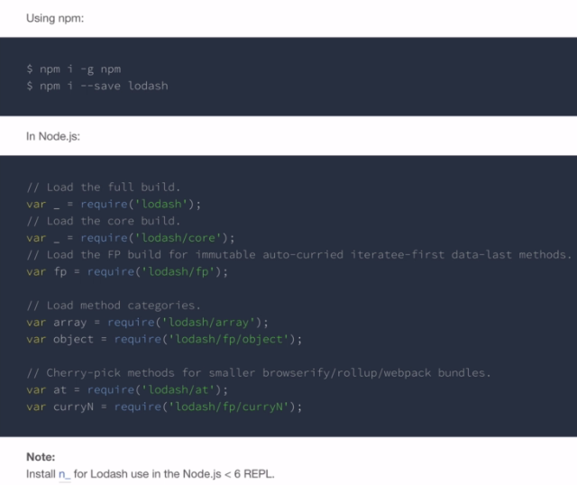

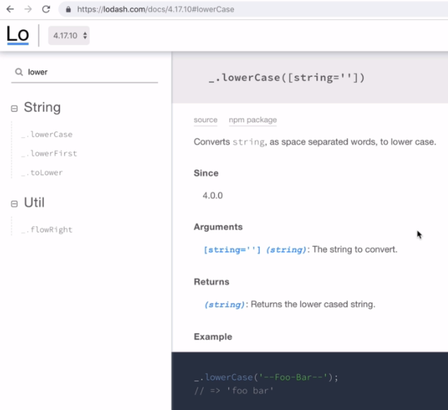

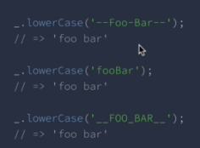

Install lodash:

**npm i lodash**

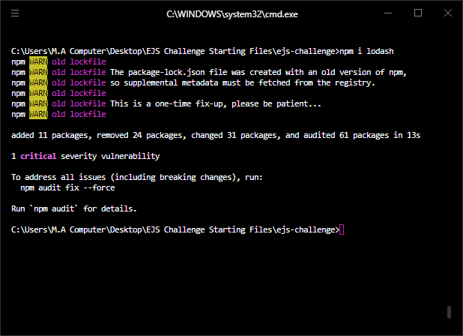

**Solution:**

const _ = require("lodash");

app.get('/posts/:postName', function(req, res) {

const requestedTitle = _.lowerCase(req.params.postName);

posts.forEach(function(post) {

const storedTitle = _.lowerCase(post.title);

if (requestedTitle === storedTitle) {

console.log("Match found!");

} else {

console.log("Not a Match!");

}

});

});

Now add new posts and search like

<http://localhost:3000/posts/another%20post>

<http://localhost:3000/posts/another-post>